**Favourites**

Colour: Teal

Animal: Owl

Food: Roast

Flower: Pansy

Film: Something from Disney.

Country visited: France

Beach: Chapel Porth

**About Me**

I am a proper Cornish person. I was born where I expect most of you were born at Treliske hospital. I have two children Daisy who is 5 and Holly who is 2.

My main hobby is being involved in Porthtowan Players Amateur Dramatics society. I have been part of the society since I was 5 years old. During this time, I have taken on many different roles both onstage and off. My most recent accomplishment with the society is producing the pantomime of Jack and the Beanstalk. I also enjoy spending time with my family, going for walks and exploring different places in Cornwall.

Something exciting that will be happening to me is I am going to get married in November 2024. My name will then be Mrs Mills.

**Welcome**

Our classroom for the next year will be Truthan class. I am looking forward to the challenge of teaching Year 3/4 with Mr Cameron who will be teaching on a Monday and Tuesday.

It will be nice to teach you all again as I have taught most of you before. Some of you were in one of my first nursery classes.

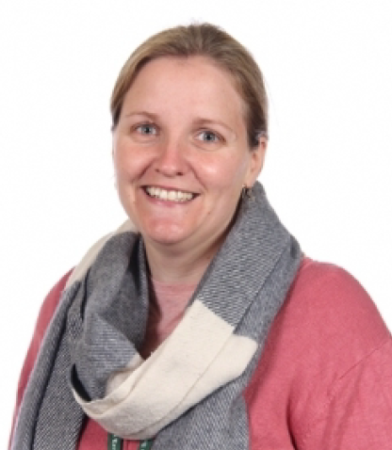

**Miss Gardner**