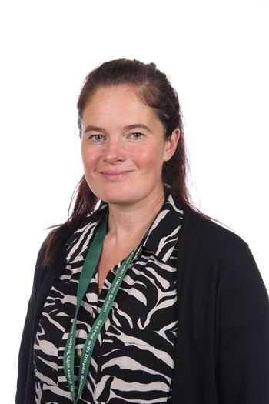

Mrs Mullineaux

**Welcome**

Hello! I’m Mrs Mullineaux and I will be your teacher in Frogmore Class. I have a real passion for Early Years education and specialised in this area during my teacher training. It is such a privilege to be involved in your very first experiences of school life and watch you grow in confidence, explore new experiences and develop wonderful friendships during your Reception year. I am passionate about wellbeing and emotional development and so ensure our classroom is a nurturing environment for you to feel happy and comfortable in with our encouraging and supportive EYFS team. There are learning opportunities all around us so we will enjoy lots of different learning experiences both indoors and outdoors – I know we are going to have so much fun together!

**About Me**

I moved to Cornwall from the Lake District 10 years ago and have recently moved into the village here in St Erme. I live with my husband and two children as well as our chocolate Labrador dog, Edgar. In the summer holidays we are also getting a new puppy called Pepsi!

In my spare time, I enjoy being outdoors (in all weather!), going for walks and gardening.

I also enjoy going out for meals and shopping with my family as a special treat.

**Favourites**

Colour:Turquoise

Animal: Horse

Food: Steak

Flower: Peony

Film : Sing 2

Book: Bog Baby

Country visited: Cuba

Beach: Porthtowan