
October 2025
SEND NEWSLETTER AND INFORMATION St Erme with Trispen Primary School Summer Term 2026
The first half of the Autumn term has flown by! The Autumn term is such an exciting time in school and we are looking forward to the run up to Christmas!
This year, Mrs Drake is still acting SENDCo, Miss Cotterill will be starting her SENDCo NPQ and Mrs Doyle will be starting her Assistant SENDCo qualification. We will be working together as a team to support and enhance SEN provision throughout this year.
Much work has taken place behind the scenes in school with regards to SEN so far this term and we wanted to share some of this with you, as well as to provide you with additional information and support. As ever, please do contact us in the office if you have any concerns or questions and we will be happy to help.
Mrs Drake, Miss Cotterill and Mrs Doyle

IPM Meetings
Your IPM (Individual Provision Map) meeting will be taking place with your child’s class teacher over the next few weeks. This will involve reviewing previous targets and setting new SMART targets, so that they are achievable for the children at the end of term when they are reviewed.


Having a good understanding in school of children who demonstrate Neurodiverse behaviours is one of our strengths here at St Erme with Trispen School. There is a new Profiling Tool available to use if a child is demonstrating behaviours either at home or in school that are linked to ASD or ADHD. If we think that your child might benefit from further support with this, you would have been contacted and will be in the process of meeting your child’s class teacher to complete the Profile Assessment Tool. A plan, similar to that of an IPM, will then be completed for your child. This profile replaces the work that County used to do when they used to come into schools to carry out their own assessments. Schools are now expected to complete these and then action the plan for a 12-week period, to then be reviewed and/or referred to Cornwall Council. More information on this process can be found by scanning the QR code.
This has been created and implemented throughout school, so that children are receiving appropriate, meaningful interventions to support their learning. This is working very well and is supporting the learning that is taking place in the classrooms as well as reflecting the support that is included within your child’s IPM document.

Within the classrooms… there are a range of strategies that are used to support all learners to achieve. This is known as the Universal Offer. If your child has an IPM or an EHCP, there are more targeted and specialist strategies that are used within the classroom so that all children can access their learning and achieve. Please click here for our School Offer Provision Map or look under the inclusion tab on our website for further information.

A timetable of Interventions


Other Updates: Our Record of Need is up to date which is a register of all children who have an IPM. This shows that we have 22.6% of our children on the Record of Need, with the National Average for Primary schools being 14.2% and the average for Cornwall sitting at 20%. Our Record of Need will be reviewed on a yearly basis and Parents and carers will know if their child is on this document, but if you are unsure, please do speak to either myself or your child’s class teacher.


Monday 6th October – Friday 10th October is Dyslexia Awareness Week. As part of this, on Friday 10th October, the Cognition and Learning team will be delivering an assembly on barriers to learning to raise awareness and celebrate learning differences.

Parent Café – Friday 10th October
2-3pm

Following the assembly, the Cognition and Learning Team will be holding a drop-in parent café from 2-3pm. Please pop in and see them with any questions you may have, or for any advice you would like to seek regarding your child’s barriers to learning and how you can support them with these at home.

Finally…
I hope that you enjoyed coming in to school for our Macmillan Coffee afternoon last week. Watch out for further dates of drop in afternoons; it was lovely to see you in school!
Warmest wishes
Mrs Drake
Mrs. Drake
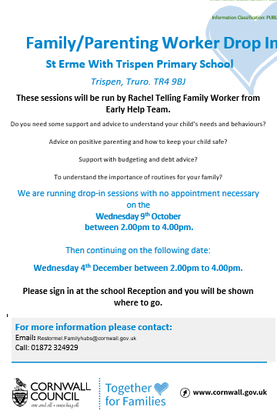
Parent Zone
Rachel from the Early Help Hub will be here for a drop-in session on Thursday 2nd October between 2 pm and 4pm. Please pop in and see her with any questions you may have, or for any advice you would like to seek. Rachel will be able to guide you to the many services the Early Help Hub can offer.
If you would prefer to make a private appointment with Rachel, please contact the school office and we will make sure a time slot can be arranged with Rachel.
If you would like more information on the services the Early Help Hub can assist you with, please click on the QR code below.

Early Help Hub Drops ins
Dates for the remainder of the year:
- Thursday 2nd October
- Thursday 4th December
- Thursday 12th February
- Thursday 26th March
- Thursday 21st May
- Thursday 2nd July

