
February 2026
SEND NEWSLETTER AND INFORMATION St Erme with Trispen Primary School Spring Term 2026
Welcome to this edition of our SEN newsletter. This term, we are continuing to strengthen the support we offer across our school community, with a focus on wellbeing, inclusion and ensuring every child can thrive.

We are pleased to welcome Jon Evison from the Mental Health Support Team, who will be visiting school each week. Over the coming terms, we look forward to seeing how this additional wellbeing support develops and benefits our whole school community.

As ever, please do contact us in the office if you have any concerns or questions and we will be happy to help.

Mrs Drake, Miss Cotterill and Mrs Doyle


IPM Meetings
Your IPM meeting will be taking place with your child’s class teacher over the next few weeks. This will involve reviewing previous outcomes and setting new SMART outcomes that are carefully tailored to your child’s identified needs and the barriers that may impact their learning. This will help to ensure that provision is targeted and effective in supporting your child to make progress.

Our intervention timetable offers a range of supportive programmes tailored to pupils’ needs. These include class-based interventions to strengthen core learning skills, working memory sessions to boost focus, Fun-Fit activities to develop coordination, and speech and language support to enhance communication. Forest School also provides meaningful outdoor learning that builds confidence and independence. Together, these interventions help every child grow and thrive.

Within the classrooms… there are a range of strategies that are used to support all learners to achieve. This is known as the Universal Offer. If your child has an IPM or an EHCP, there are more targeted and specialist strategies that are used within the classroom so that all children can access their learning and achieve. Please click here for our School Offer Provision Map or look under the Special Education Needs and Disabilities tab on our website for further information.
A timetable of Interventions
Book recommendations

We’re Going on a Bear Hunt is a fantastic story for building children’s language skills through repetition, rhythm, and predictable patterns. Its vivid sensory descriptions and actions also encourage engagement, movement, and imaginative play—making it especially supportive for pupils with SEN who benefit from multisensory learning.

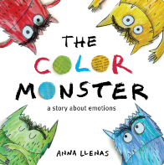
The Colour Monster is a wonderful tool for helping children understand and talk about their emotions in a clear, visual way. Its simple language and engaging illustrations make it especially supportive for pupils with SEN who benefit from concrete, visual representations of feelings.

Other Updates: Our Record of Need is up to date which is a register of all children who have an IPM. This shows that we have 28.4% of our children on the Record of Need, with the National Average for Primary schools being 15% and the average for Cornwall sitting at 20%. Our Record of Need will be reviewed throughout the year and Parents and carers will know if their child is on this document, but if you are unsure, please do speak to either myself or your child’s class teacher.

Working memory

What is Working Memory?
Working memory is the brain’s “holding space” — it’s how we keep information in mind long enough to use it. Children use working memory every day: remembering instructions, following steps, doing mental maths, writing sentences, and staying focused on tasks.
For many learners with SEND, working memory can be a challenge. When working memory is overloaded, children may forget what they’re doing, lose track of instructions, or struggle to start or finish tasks. Supporting working memory means reducing the load and helping children keep information manageable, so they can learn and feel successful.

Supporting working memory
- Give short, simple instructions – break tasks into one or two steps at a time.
- Ask your child to repeat instructions back. For example, asking, “Can you tell me what you need to do?” helps them to hold the information in their mind.
- Create routines – Morning, homework and bedtime routines reduce how much your child has to remember. Perhaps use visuals to support this for younger children.
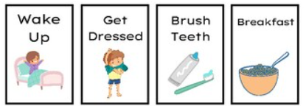

Working memory games
1. “I Went to the Shop…”
A classic memory chain game. Each person adds an item:
“I went to the shop and bought… apples… apples and bread… apples, bread and milk…”
Great for auditory memory and information recall.
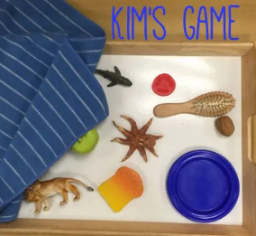
2. Copy My Clap
Take turns clapping a pattern and asking your child to repeat it. Start simple and gradually build up. You can also use tapping, clicking or stomping sequences.
3. Kim’s Game
Place 6–10 objects on a tray. Let your child look for a few seconds, cover it, then ask them to recall what they saw. You can also secretly remove one item and ask, “What’s missing?”
4. One-Minute Memory Hunt
Give your child 30 seconds to look around a room, then ask questions like:
“What colour was the cushion?”
“How many books were on the table?”
Boosts visual working memory
Parent Zone
Rachel from the Early Help Hub will be here for a drop-in session on Thursday 12th February between 2 pm and 4pm. Please pop in and see her with any questions you may have, or for any advice you would like to seek. Rachel will be able to guide you to the many services the Early Help Hub can offer.
If you would prefer to make a private appointment with Rachel, please contact the school office and we will make sure a time slot can be arranged with Rachel.
If you would like more information on the services the Early Help Hub can assist you with, please click on the QR code below.

Early Help Hub Drop ins
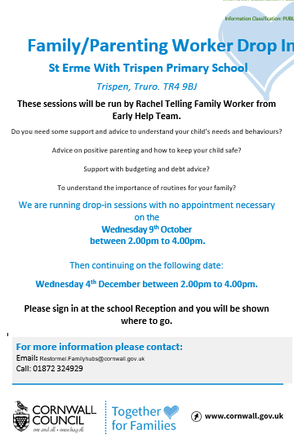
Dates for the remainder of the year:
- Thursday 12th February
- Thursday 26th March
- Thursday 21st May
- Thursday 2nd July
Finally…
Thank you for your continued support. We look forward to working with you throughout the term to ensure every child receives the provision they need to succeed. If you ever have questions, concerns, or would like to discuss your child’s needs further, please feel free to get in touch. We are here to support you and your child every step of the way.
Mrs Drake

Mrs. Drake

