**About Me**

My name is Mr Cameron and I will be teaching every morning in Year 4 this year, alongside my role as deputy headteacher.

Outside of school, I love to spend time with my wife and my daughter, Olive. Together, we love finding new places to walk our sprocker spaniel called Rory.

I have always been very interested in sport. Golf has always been my favourite and I’m still continuing to pursue my goal of getting my handicap under 3. You’ll probably catch me practicing my swing on the playground! Alongside golf, when I get the chance, I love to ski. Unfortunately, in Cornwall, we don’t get much snow so any holidays normally involve a trip into the alps and a good blast of fresh mountain air.

**Favourites**

Colour: Orange

Animal: Dogs

Food: Pizza

Flower: sunflowers

Film: Happy Gilmore

Book: A Song of Ice and Fire by G.R.R. Martin

Country visited:

New Zealand

Beach: Porthkidney

**Welcome**

What can you expect in Year 4?

This year, I will be teaching Year 4 every morning before they return to Mrs Frazer in Trevella for the afternoons. We will cover some amazing genres in English and continue to improve our mathematical thinking.

This year, I’m really looking forward to our writing journey. We have some amazing stories and texts to base our writing on and I’m looking forward to seeing how you all progress next year.

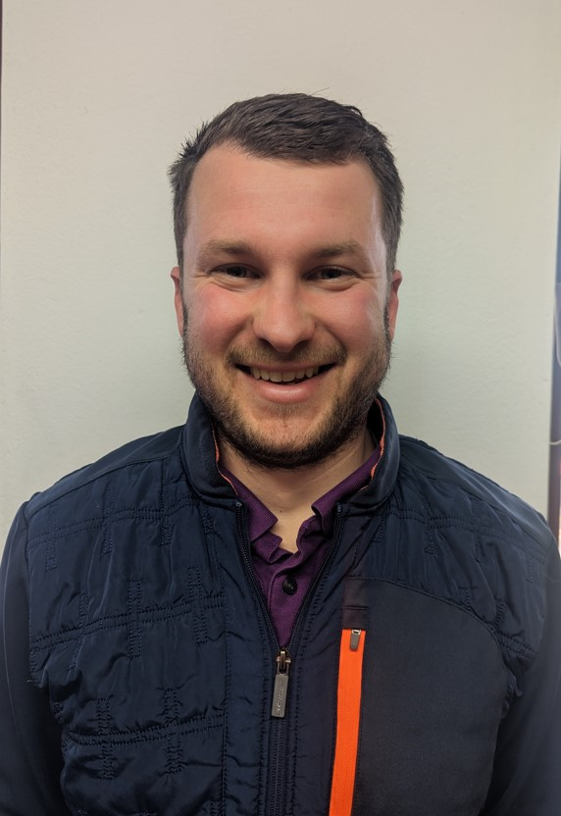

Mr Cameron