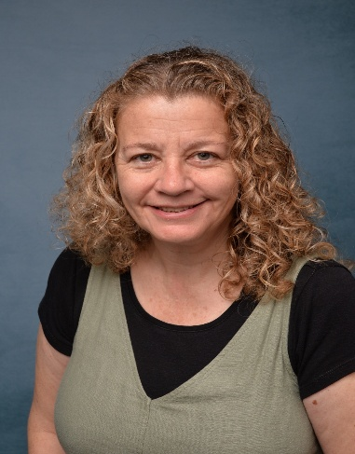
Mrs McNamara
Welcome
I’m Mrs McNamara and I will be continuing the HLTA role I’ve had for the last few years covering teachers’ PPA time which makes me lucky enough to work in every classroom across the school!
Having been a Key Stage Two teacher for many years previously, I really enjoy the opportunity to still work in those year groups but also experience the world of Key Stage 1 and EYFS.

About Me
I was born and bred in St Erme as my family have lived here for generations. I went to the old village school, Penair and Truro VI Form (now Sainsburys!) then moved away to the bright lights of London for university where I trained to be a Primary School teacher.
Finally returned home in 2009 with my daughter Freya, who I might mention a bit as she’s my favourite thing but that wasn’t on the list!
I started working at St Erme in 2014 so am probably quite a familiar face having taught a few members of the same families. It’s really been a pleasure to watch everyone grow up and come back from time to time.
In my spare time, I am mainly chauffeur to my 17-year-old but when I get some free time I love going to watch a good show at the Hall for Cornwall – the last one we saw was ‘& Juliet’-going to the beach or just chilling at home reading a good thriller.

.

Favourites
Colour: Green

Animal: Wombat

Food: Chocolate Cake

Flower: Daffodil

Film: Maleficent

Book: Harry
Potter and the Deathly Hallows

Favourite country visited: USA - New York
Beach: Holywell Bay

