
June 2026
SEND NEWSLETTER AND INFORMATION St Erme with Trispen Primary School Summer Term
It has been another busy term, with lots of targeted interventions taking place to support our pupils’ individual needs and help them thrive.
We would like to thank Jon Evison, our Mental Health Practitioner, who led a parent workshop on supporting children with their worries. He has since begun working with more pupils, offering valuable support for their emotional wellbeing.
As we begin to think about transition, we understand that this can be both exciting and challenging for children. Please see below for some helpful ways you can further support your child during this time.
Thank you, as always, for your continued support—it truly makes a difference.
Mrs Drake and Miss Cotterill

IPM Meetings
Your child’s IPM (Individual Provision Map) meeting will be taking place with their class teacher over the next few weeks. This will involve reviewing previous targets and setting new SMART outcomes, so that they are achievable for the children. They will then be reviewed during the Autumn term and new outcomes set.

Supporting your child with transition
Transition to a new class can be an exciting time, full of opportunities and new experiences. However, for some children it may also bring feelings of worry or uncertainty, which are completely normal. At our school, we recognise this and take a range of steps to support a smooth and positive transition for all pupils. These include ‘move up’ mornings where children spend time in their new classroom, as well as transition meetings between current and new class teachers to share important information and ensure each child’s needs are understood. By working together, we aim to help every child feel confident, prepared and ready for their next step.

Below are some things that you can do at home to further support your child with the upcoming change and their feelings surrounding it. Please note that not all strategies will support every child and it is your

Countdown to the transition:
For some children, regular time reminders in preparation for transition can help them mentally prepare. Your child is more likely to feel like they are in control of a situation if they know what’s coming up. You could create a countdown to key dates, such as ‘Move up morning’, ‘End of term’, and ‘First day of term’.

Talk, talk, talk:
Talk to your child about the changes that are happening and give them time to share their feelings about it. Talking can help to relieve fears and see change in a positive way. Try giving them a time to share their worries but avoid doing this at bedtime. Instead, at bed time, ask them to name something they are looking forward to or are excited about in their new class. This helps to

Social story:

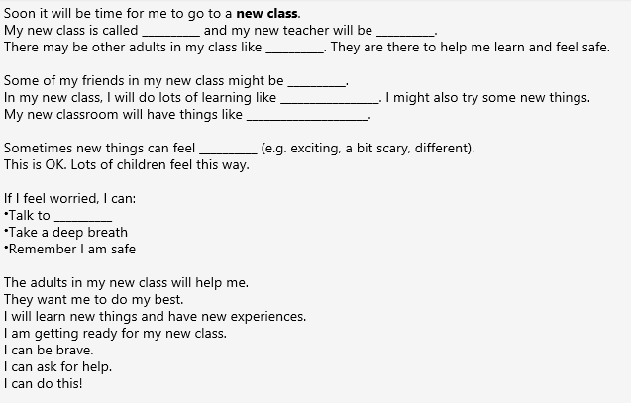
Social stories are a great way to support children with change. They are short, simple stories that can help children understand what to expect in different situations and how they can respond. In turn, this can reduce worries and support communication and emotion regulation. They should be used regularly and consistently, in a calm, supportive way. An example of a social story to support transition is attached. Please feel free to use this with your child if you feel it would be useful, and add information as needed.

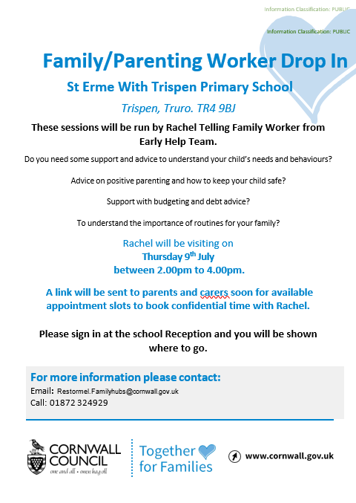
Parent Zone
Going forward, if you would like to meet with our Family Worker, Rachael Telling, we kindly ask that you book an appointment in advance. This helps ensure that everyone who wishes to see her has a protected time slot, and it also allows Rachael to plan how many families she will be supporting during each visit.
If you would like more information on the services the Early Help Hub can assist you with, please click on the QR code below.

Early Help Hub Drops ins

Dates for the remainder of the year:
- Thursday 9th July

