**Welcome**

I can’t wait to be your teacher again next year and to be welcoming some new children to the class. I think the most important part of my job is to make sure you are happy, to make learning fun and get the best work from you that I can. I am excited about moving in to Trevella classroom and learning so many new things with you.

**About Me**

I was born in Montreal which is in Canada. When I moved to this country, I lived in the south of England and moved to Cornwall to start my first job as a teacher. I knew from the age of 6 that I wanted to be a teacher and I think it’s the best job in the world because no 2 days are ever the same. I have worked at St Erme for 29 years (because I love it so much) and taught quite a lot of your parents when they came to this school. I have 4 children – 2 boys and 2 girls who keep me very busy. However, I love to walk along the beach and play tennis when I have time. My Dad was Scottish, and I love going there as it is very like Cornwall. That’s where I discovered white pudding which is made from oatmeal, onion and spices. Delicious!

**Favourites**

**Colour:**

Purple

**Animal:**

I don’t have one

**Food:**

White pudding

**Flower:**

Sunflower

**Film :**

Notting Hill

**Book:**

A Christmas Carol

**Country visited:**

Switzerland

**Beach:**

Crantock

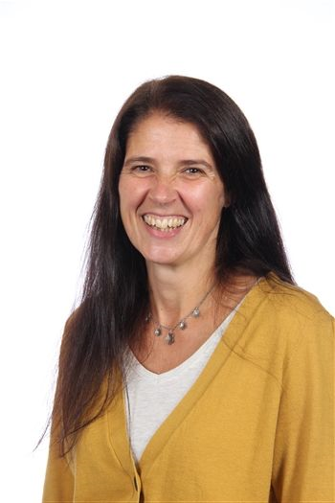

Mrs Frazer