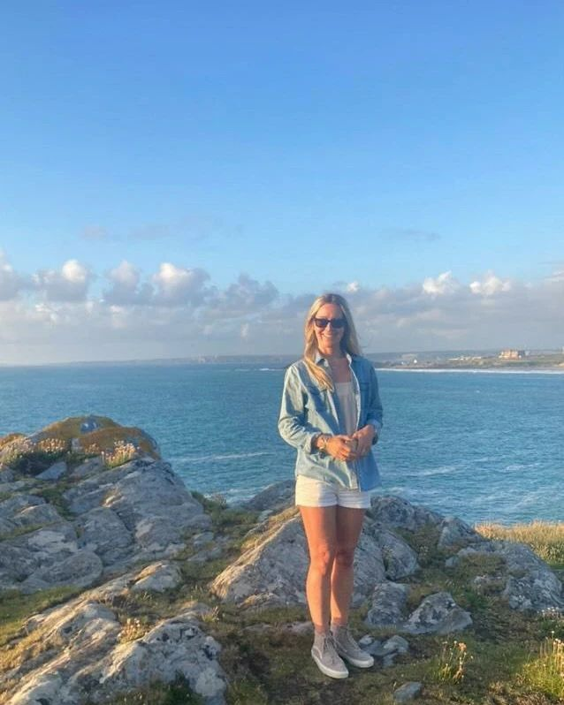

**Favourites**

Colour: turquoise like a tropical sea.

Animal: I love all animals and have a black cat called Squidge.

Food: I’m a vegetarian and love all food, particularly pastries, cake and curry!

Flower: bluebells and frangipani

Film : I’m not really a film fan!

Book: I love reading so there are too many to mention. My favourite book as a child was The Magic Faraway Tree.

Country visited: Australia, Indonesia and Sri Lanka…

Beach: Fistral Beach is my local beach and Wategos Beach in Byron Bay.

**About Me**

I grew up in Lancashire before moving to Newquay when I was 21 years old, so I’ve lived in Cornwall now for quite some time. Before becoming a teacher, I spent many years traveling around the world visiting lots of incredible places. I have snorkeled with turtles in Sri Lanka, been whale watching and surfing in Australia, hiked through jungles in Indonesia, and climbed Table Mountain in South Africa.

In my free time, I enjoy walking around the beautiful Cornish coast and spend as much time as I can at the beach! I love being outdoors with my friends and family exploring new places. As I live in Newquay, we often go paddle boarding down the River Gannel or at Fistral Beach if there isn’t too much surf. I also love music and festivals and often see families from our school enjoying themselves too!

There isn’t much that I’m afraid of but I am absolutely terrified of sharks. I can’t even look at pictures of them!! Luckily we don’t get many in Cornwall.

I look forward to getting to know you all too. Have a fantastic summer, see you soon!

**Welcome**

Welcome to Boswiddle Class. I’m really looking forward to being your teacher next year and I’m sure that we are going to have lots of fun. I’m looking forward to getting to know all of you and the things you like to do. We will have lots of exciting things to look forward to, such as painting and drawing, making Tudor houses, playing lots of games in PE as well as becoming marvellous mathematicians and writers.

Have a fun filled summer!

Mrs Hall

Mrs Hall