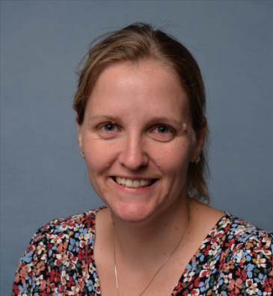
Mrs Mills
Welcome

This year I am lucky enough to be working with three different year groups. This means I will have the pleasure of teaching many of you again. I am really looking forward to seeing how you have all developed in confidence, and also academically.

About Me

I have lived in Cornwall all my life and enjoy exploring the Cornish countryside with my family. I have two children of my own who keep me very busy!!

One of my favourite past times is amateur dramatics. I am the chairperson of a local group, which I have been involved with since I was 5 years old. During this time I have taken on many different roles within the group both on and off the stage.

Favourites
Colour: Aqua

Animal: Sloth

Food: Roast dinner

Flower: Pansy

Film: The lion king

Favourite country visited: France

Beach: Chapel Porth

